Name:______________________________ Pd:_____ Date:________________
Protist Station
Station1: Matching #1
Name of Protist | Name of Protist
1. | 1.
2. | 2.
3. | 3.
4. | 4.
5. | 5.
6. | 6.
7. | 7.

Station 2: Protists Reading
1. In general, the Kingdom Protista contains: Organisms that must get their food from other organisms Organisms that make their own food Organisms with a membrane-enclosed nucleus and who don't fit in any other kingdom | 2. Most protists move with the help of: Cilia, flagella, or pseudopods Euglena and amoeba Muscles and bones
3. You would find most protists living in: Antarctica A moist environment A desert | 4. What does pseudopod mean? False foot Making seed pods False animal
5. What are pseudopods used for? Moving Trapping food Both a and b | 6. What are cilia? Hair-like projections A type of chemical in the cell Silly feet
7. What are flagella? False feet Whip-like structures that spin quickly Flags that show protists where to go | 8. Where do Protists mostly live?  - In people's homes, beds, couches and dirty clothes  - They live in rotten food and moldy cheese  - In wet places, such as oceans, lakes, ponds, rivers and streams  - On hairy animals such as bears, dogs, cats, mice and even pigeons
Are Protists dangerous?
- Yes, they can cause dangerous diseases like malaria and sleeping sickness
- No, they are far too small to harm anyone
- No, they are healthy to eat and are used to kill off bad bacteria in water

Station 3: Algae in your House?

Name of Food | Carrageenan | Beta Carotene | Agar | Alginates
Whipped Cream

Oriental Noodles

Soy Milk

French Vanilla Creamer
Chicken Soup

Egg Beaters

Vanilla Pudding

Fruit Pies

Nutri-Grain Bar

Margarine

Gerber Graduates Cookies

Station 4: Matching #2
Name of Protist | Name of Protist
1. | 1.
2. | 2.
3. | 3.
4. | 4.
5. | 5.
6. | 6.
7. | 7.
8. | 8.

Station 5: First Look

Paramecium | Amoeba
Volvox | Euglena

Describe in your own words what each organism looks like. BE SPECIFIC!
Paramecium
Amoeba
Volvox
Euglena

Station 6: The Amoeba &Paramecium Readings
Amoeba
- Why are amoebae called “shape-shifters?”

- How do Amoebae move?

- What do amoebae eat?

- How do amoebae eat?

- Why is a pseudopod important to an amoeba?

Paramecium
- What does it mean to be single-celled or unicellular?

- What is the purpose of cilia for and why are cilia so neat?

- Do paramecium reproduce sexually or asexually? Explain what this means.

- Are paramecium autotrophs or heterotrophs? Explain. (Think about what they eat)

- What happens when a paramecium meets a predator

- How are paramecium helpful? How are they harmful?

- Why are paramecium the most complex of the protists?

Station 7: The Euglena &Volvox Readings
Euglena
- What does the flagella do for the Euglena?

- Is a Euglena a heterotroph or an autotroph or both? Explain.

- What do chloroplasts do for the Euglena?

- What does the eye spot do for the Euglena?

- Describe the movement of a Euglena.

Volvox
- What is an example of a Volvox?

- About how many volvox live together in a colony?

- What purpose do flagella serve for the Volvox?

- How do Volvox obtain food energy?

- What does chlorophyll help the volvox do?

- How do volvox reproduce?

- How are volvox helpful/harmful to humans? Why?

Station 8: Disease Causing Protists #1
Disease name | Malaria
Protist name
Transmission
(how does the disease spread?)

Symptoms

Treatment

Prevention

Disease name | Primary Amebic Meningoencephalitis
Protist name
Transmission
(how does the disease spread?)

Symptoms

Treatment

Prevention

Station 9: Disease Causing Protists #2
Disease name | Amebiasis
Protist name
Transmission
(how does the disease spread?)

Symptoms

Treatment

Prevention

Disease name | Giardia
Protist name
Transmission
(how does the disease spread?)

Symptoms

Treatment

Prevention

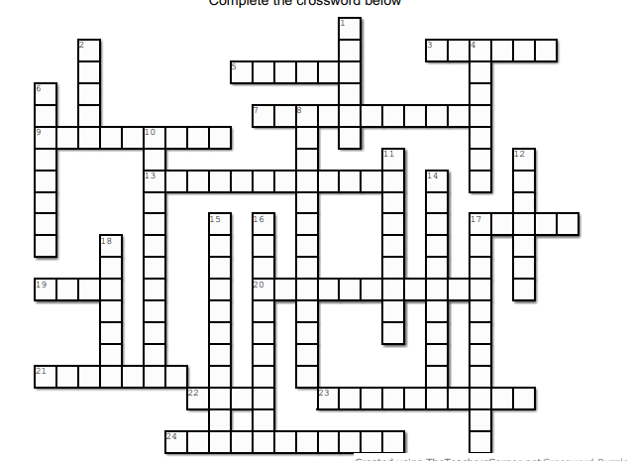
Station 10: Crossword Puzzle

